**Snake Cave:** a game where you control a snake, and collect pieces of candy to grow longer. The goal is to score as many points as you can before you hit the wall or your own tail.

**Technology:** C# +Unity 3D

**Mockup:**

**Features:**(P1) Game Scene

* (P1) User-controlled snake
* (P1) Random generated walls
* (P1) Candy objects spawning on a random spot between the walls
* (P1) Snake gets longer when picking up candy
* (P1) Collision detection between snake and wall, and snake and tail
* (P2) Baby snakes inside a small cave you can feed to get shorter
* (P2) Score display
* (P3) Sound effects

(P2) Start Scene

* (P2) Play button
* (P3) Options button

(P3) Options Scene

* (P3) Music volume slider
* (P3) Difficulty

(P2) End Scene

* (P2) Score
* (P2) Back button
* (P3) High score

(P1) top priority  
(P2) middle priority  
(P3) lowest priority

**Mockup:**

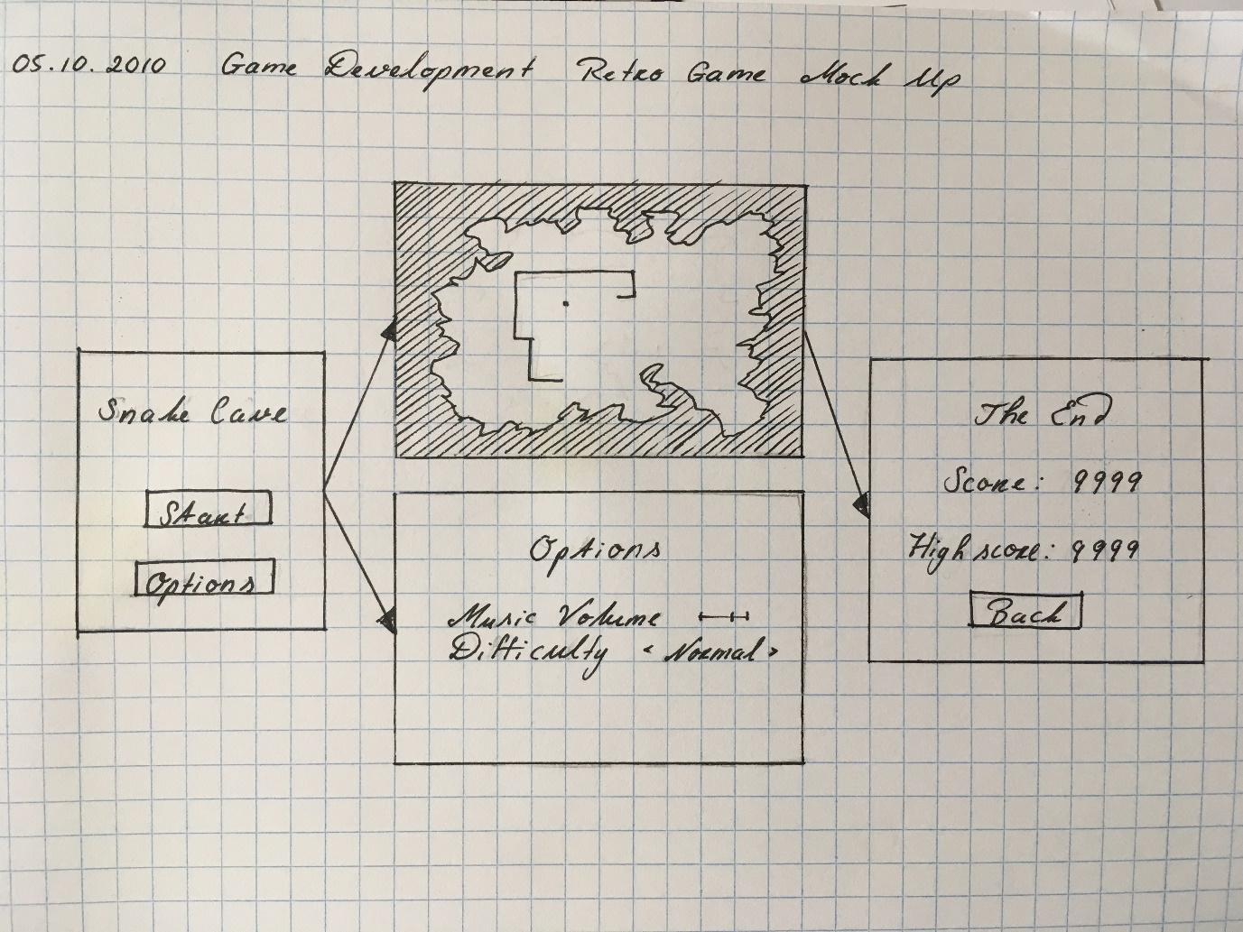

**Design Patterns:**Object Pool

Singleton